Meta Description:
LinkedIn marketing is an effective technique to promote a brand, and its products & services on LinkedIn for better engagement, lead generation & connection building.

What is LinkedIn Marketing & How to Do It in 2025
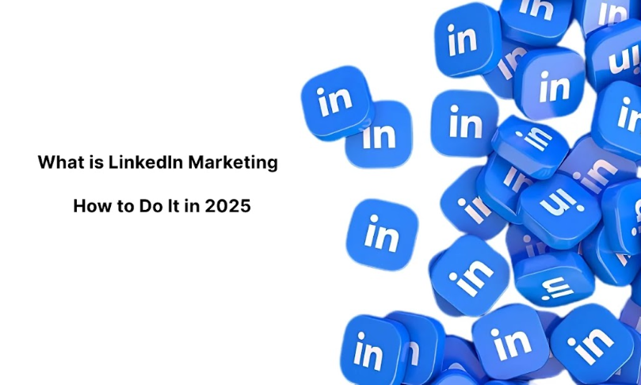

LinkedIn has remained one of the most effective social media platforms that help professional people connect, share, and market their businesses worldwide. When focusing on the future expanded plan for 2025, it is crucial for any business to have a LinkedIn marketing plan. Here you will learn about what LinkedIn marketing is, why it should be implemented by businesses and organizations, and the right ways that can be employed to make LinkedIn marketing more effective in the future.
Additionally, you will also learn about LinkedIn marketing step-by-step and how to create your business page, you will also learn how to enhance it by using paid and free tools for LinkedIn marketing.

1. What is LinkedIn Marketing?
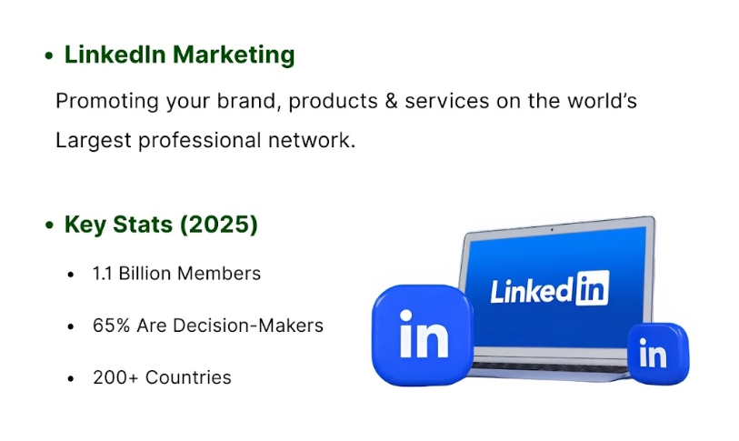
LinkedIn marketing can be defined as the process of advertising your brand, reaching out to other business people, and expanding your business through the use of LinkedIn. In contrast to different social media that are principally founded on social interaction, LinkedIn is a business-oriented site. It works effectively for business, raising the consciousness of a precise group of clients, interacting with industry professionals, and promoting experience.
As per the LinkedIn report of 2025, this platform has over 1.1 billion members worldwide as of January 2025 and most of these people belong to the category of decision-makers and other influential users. In particular, it yields a vast number of professionals, which makes LinkedIn an excellent tool for companies interested in increasing their presence on the Web.
Key Components of LinkedIn Marketing:
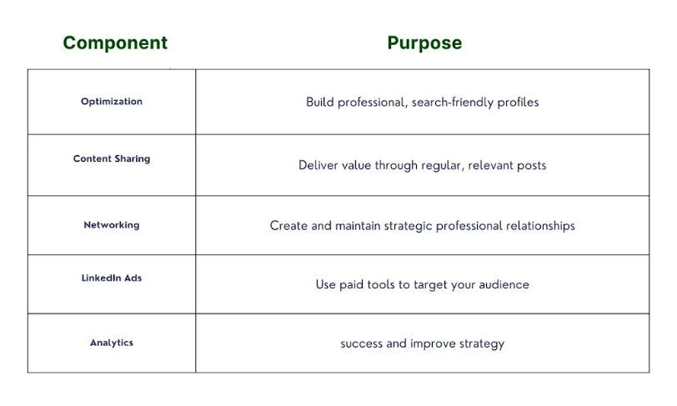
- Optimization: Writing exciting text for LinkedIn accounts for particular people and companies.
- Content Sharing: It involves publishing and sharing content because this is what the audience wants to see from a page.
- Networking: How to foster the connections used by any professional
- Adverts: You can utilize paid advertisement opportunities to have access to the larger community.
- Analytics: The process of evaluating and quantifying your current LinkedIn marketing to find gaps in the current techniques.

2. The Importance of Using LinkedIn Marketing for Business:
LinkedIn marketing is very important for several reasons, especially as we approach the year 2025. The following are some of the reasons why it is important for any business to consider LinkedIn marketing:
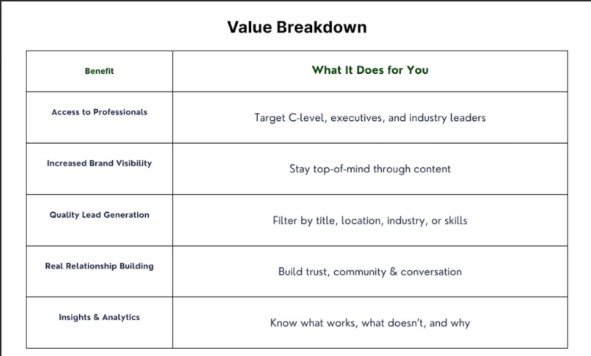

a. Access to a Professional Audience
Using over 1.1 billion people across the world as members, LinkedIn is currently the biggest professional network. It should be noted that this number will only increase by 2025, to about mid-twenties. It offers a huge customer base to companies trying to have access to business personnel, besides ensuring that a company reaches the key decision-makers within the profession.

b. Enhanced Brand Visibility
Having a strong presence on this platform creates awareness of your brand. Through posting quality content and interacting with the audience, there are high chances of making yourself and your business recognized as the go-to expert in your line of business. This visibility will help in making the brand more identifiable and recognizable to the public.

c. Lead Generation and Conversion:
LinkedIn is a useful platform, especially for generating quality leads. For instance, LinkedIn’s Sales Navigator or LinkedIn Ads enables organizations to target a specific demographic, some areas, or the title of employment. This makes it easier to capture and transform the identified leads into customers.

d. Networking and Relationship Building
LinkedIn facilitates networking and relationship building. It is quite beneficial for the buses to get associated with peers in the industry, join specific groups, and also contribute to the discussions, which can lead to improved relations and numerous opportunities for operations such as collaborations.

e. Insights and Analytics:
LinkedIn offers business cognition and analytical figures that enable organizations to gain an understanding of their target market or appraise the effectiveness of their marketing campaigns. It allows evaluating the general engagement rates, CTR, and the number of leads, which will help a business adjust its actions to maximize the ROI.

3. How to Build a LinkedIn Marketing Strategy?
The following are the strategic steps that you need to follow when put into practice to develop a good LinkedIn marketing strategy. Here, you will find the step-by-step guide that will assist in developing a proper plan for your company for the year 2025 and beyond.
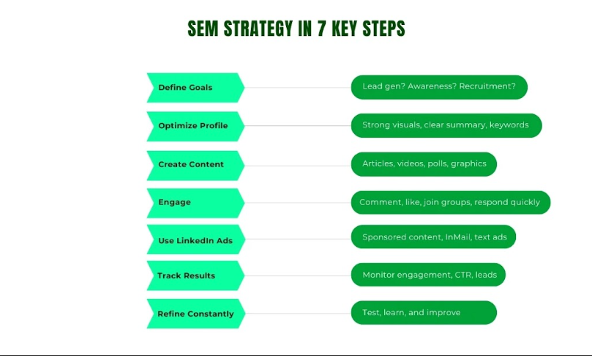

a. Define Your Goals
For anyone involved in marketing, it is important to begin by identifying your goals on LinkedIn. Do you need brand visibility, business leads, or to get your business idea passed into the minds of a wider client base regularly? This will help you in measuring the outcomes that are expected to be achieved in the framework for the strategy. This may range from having a target of increasing your followers by 20% or acquiring not less than a hundred leads per month.

b. Optimize Your LinkedIn Profile
LinkedIn profile is the online professional identity of users. It can be compared to a business card in a certain sense. This optimization process will make both your individual and business-related media accounts the best among the rest competitors. This includes:
- Profile Picture and Cover Photo: As with the profile picture, settle for a professional and quality picture as the cover picture.
- About Section: Ensure you write a convincing value proposition statement to clearly state the purposes of your business website
- Experience and Achievement: Much focus should be put on your experience and any achievements that have been made.
- Recommendations and Endorsements: Persuade colleagues to write recommendations and endorse your business skills.

C. Create and Share Valuable Content
Content is king on LinkedIn. Create informative and relevant posts that would be of interest to the readers who are subscribed to your page. This can include:
- High Level of Work: Write more enhanced, informative, and prescriptive articles and blogs that focus on reaching the destination.
- Use of Videos and Infographics: You should use videos and infographics to reach the target market to share large quantities of information.
- Case Studies and Testimonials: Showcase your success stories and client testimonials.
- Industry News and Trends: It is crucial to share interesting industry news and trends to create a form of perception that you are well-informed and knowledgeable.

d. Engage with Your Audience
Engagement with your audience is very important when it comes to relations and visibility. You can engage with your audience by:
- Engaging in Discussions: Reply to posts with meaningful comments on the posts made by the connections and others in the relevant industry.
- Join Groups: It is important to join groups in such areas in LinkedIn-based companies to share ideas with other professionals.
- Webinars and Live Sessions: Also conduct webinars and live sessions that would help in sharing information and knowledge with the target audience.

e. Utilize LinkedIn Ads
There are various advertising opportunities available for an organization, and they include LinkedIn Ads. Here is what you can consider while using LinkedIn Ads:
- Sponsored Content: These posts can be promoted to more users and are promoted through payment.
- Direct Messages: Arrange to send specific messages to particular members.
- Text ads: Ads that appear in the form of plain text and place ed in LinkedIn’s search results in other sections of the website.

f. Leverage LinkedIn Analytics
It is useful to continue measuring the overall effectiveness of your campaigns with the help of the tools LinkedIn offers to its users. Monitor metrics such as:
- Engagement Rates: Explore how active your audience is or how they engage with the content that you have provided.
- Click-Through Rates (CTR): Measure your CTA to know how effective your call to action is.
- Leads: Determine the number of leads that have been produced as a result of your LinkedIn promotions.

g. Continuously Refine Your Strategy
Marketing is a continuous process and the same applies to LinkedIn marketing as well. Through the integration of the developed strategies, utilizing feedback and analytics, you can refine your techniques. Always be aware of new changes that LinkedIn has introduced and trends that are ongoing so you can refine your strategy even better.

h. Invest in Training and Development
LinkedIn has emerged significant tool of investment in training and development in this digital age. By getting acquainted with the latest trends and practices, it would prove incredibly vital for your business. Provide training to your personnel to increase the capability to implement your LinkedIn marketing strategy to maximum effectiveness.

2. The Process of Setting Up Corporate LinkedIn Pages:
Setting up a business account is the first step in marketing a business on the LinkedIn platform. Below is a detailed guide that would assist people who are new to LinkedIn marketing:

a. Create Your Company Page:
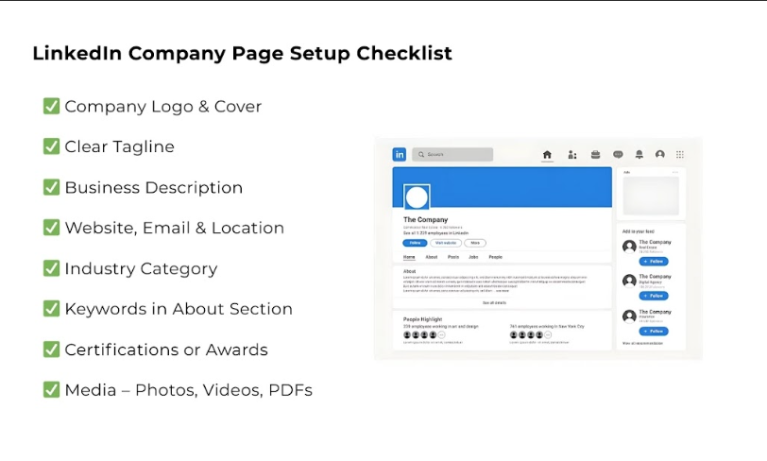
- Login: You have to be signed in on LinkedIn either through your existing account or by creating an account.
- In the same window on the left side, click on your profile picture and then choose “Manage your pages.”
- Create a New Page: Along the right-hand side, click on “Create Page” and then select “Company Page”.
- Choose the industry in which your business operates.
- Insert details such as the name of your company, the email address, the website, and the location.
- Upload Logo: This will enable the business to improve its branding by marketing its logo.
- Business Details: Provide more details regarding the additional information section so that the readers can have all-around information about the business.

b. Optimize Your Page:
- Add a Catchy Tagline: It is needed to effectively state the scope of a company and the key factors that will set it apart from competitors.
- Application of Keywords: The use of keywords will enable the searching of the information easily.
- Insert photos and Videos: Pictures and moving pictures are known to help increase engagement on posts.
- Publications/Certification: You can gain the trust of your audience easily by uploading your Publications/Certifications.

c. Engage with Your Audience:
- Consider Social Media Feed: To increase audience engagement, your post should rather focus on industry news, updates, or articles written by the company’s representatives.
- Engage with Followers: Always reply to the comments and messages.
- Join Relevant Groups: Membership in groups with relevance to your field is advisable for networking.

3. Tools for LinkedIn Marketing: Paid & Free
When optimizing the use of LinkedIn, there are paid and unpaid methods that must be used in different capacities. The following sections outline a number of the most effective options currently available:
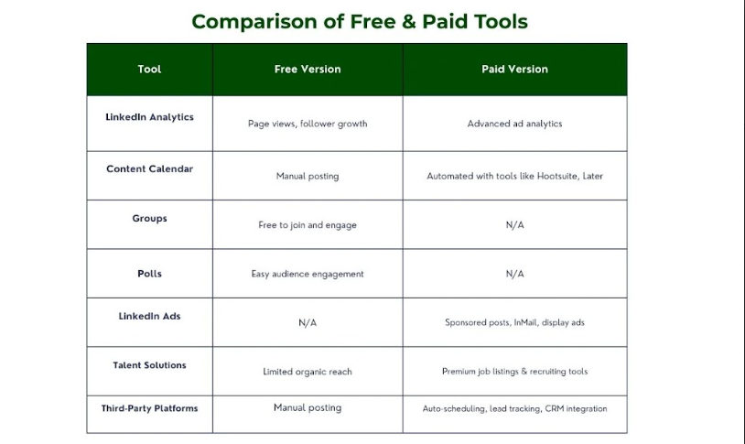

a. Free Tools:

LinkedIn Analytics:
- Analytics: This feature will help you monitor and analyze different aspects of your page. For instance, the followers’ demographics and their interaction with your posts.
- As applied: Utilize these findings to enhance the strategies that you are using in upgrading your content.

ii. LinkedIn Content Calendar:
- Frequency: As for the frequency of posting, it is advisable to plan the type of content that you will be posting at a given period to avoid inconsistencies.
- It is important to prepare a proper schedule for posting when the audience is most active.

iii. LinkedIn Groups:
- Networking: You should create Professional LinkedIn groups and ensure you add another active member of the industry to this group.
- Promotion: As part of a romotion, share posts within these groups to enhance the visibility of your brand.

IV. LinkedIn Polls:
Polls may also be used to engage your audience and obtain general information about their experience and preferences.

b. Paid Tools:

LinkedIn Ads:
- Paid Advertising: Share posts with followers of accounts that are not followers of the account being advertised.
- Targeted InMail: It allows sending messages directly to leads’ inboxes.
- Display & Text Ads: LinkedIn has also display and text ads, where small ads are posted and are noticeable at first glance on the LinkedIn home page.

ii. LinkedIn Talent Solutions:
- Recruitment: Employ LinkedIn’s features for the recruitment of candidates to join the company or organization.
- Employee Advocacy: Use employees, especially on social media platforms, to forward your message.

iii. Third-Party Tools:
- Hootsuite: Manage your LinkedIn content alongside other social media platforms.
- Later: Use Later and post your LinkedIn content in advance.
- Leadgenius: Use LinkedIn Sales Navigator for the possibility of generating and cultivating leads.

10 LinkedIn Marketing Tips to Grow Your Business in 2025
Here are some tips for 2025 regarding the use of LinkedIn for B2B marketing and networking. So, it is necessary to boil down the guidance do steps with specific statistics that will help you make the best of this platform.
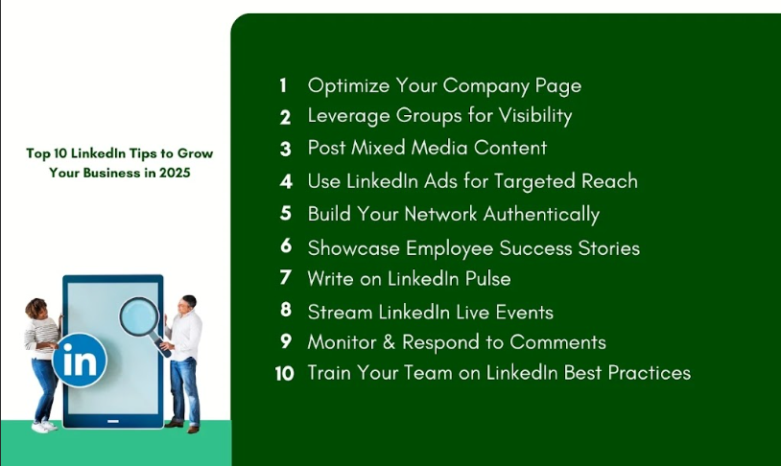

1. Optimize Your Company Page
LinkedIn Company Page plays an important role in representing your business on this social media platform in front of people or audiences. However, to make it interesting to the audience, you can rely on the best use of the tool. First, it will be useful to refresh the logo, cover image, and profile picture of the page for it to look neat. Based on LinkedIn, there is a 40% chance of receiving messages from clients if your business is fully profiled. It is also advisable to provide additional information about your business, values, and mission, as well as services. It is necessary to update the page as often as possible to ensure high activity and interest in its content.

2. Leverage LinkedIn Groups
LinkedIn Groups are one of the most valuable tools or services that can be found on the platform, which is aimed at increasing networking and brand awareness. Common discussion forums that you should be part of related to your industry of operation. This research also supports the fact that members who participate in groups have their profile views augmented by 16%, as stated by LinkedIn.
Create valuable content and make your business recognized by the audience as a provider of valuable knowledge. Another reason that you can start your group is that it allows you to monopolize a certain market by creating a group in that market.

3. Create Engaging Content
Being a professional platform, content is the king on LinkedIn, and the content that engages people effortlessly is engaging content. It is recommended to share a mixture of articles, infographics, videos, and polls to keep the audience engaged. It goes further to state that content with images or videos attracts 98% more views as compared to content without the same, and other relevant statistics. Stay on the subject matter and always try writing pieces that will benefit your readers, educate them, or inspire them with stories or examples. Be sure to incorporate analytics to measure the client experience and adjust your content creation related to it.

4. Utilize LinkedIn Ads
LinkedIn Ads are a form of advertising service that is also likely to provide good results when implemented. LinkedIn is available for marketers as it has more than 1.1 billion active users and offers niche targeting by industry, job position, and company type. There are Sponsored content, InMail, and dynamic ad options available for delivering your content to your key audience. LinkedIn reported that 61% of business-to-business marketers consider LinkedIn advertising more effective than all other social media platforms. There are some important tips that you need to observe, which include setting goals, increasing return on investment, and ROI.

5. Build a Strong Network:
Networking is the primary focus of LinkedIn. It will be important for you to ensure that you engage with people such as the key players in your niche, clients, and opinion makers. The acceptance of connection requests can be influenced by personalization, especially because of friends updating their profiles. From LinkedIn, social application users make sure that they are 50% more likely to accept such personalized requests. You should increase engagement on your account by liking, commenting on the content shared, or even sharing the content. People must work towards forging good relationships, as this improves the chances of being recommended and getting more business references.

6. Showcase Employee Success:
Employees are one of the biggest vehicles that represent an organization to the outside world. If appropriate, invite them to contribute their work to their LinkedIn profile and share their achievements. Telling stories of your employees is another effective way through which you can establish your brand. LinkedIn statistics indicate that 76% of employees have a higher level of engagement when they feel a part of success. There should be something that can show how much the company values its employees and their efforts at work, because acknowledging the latter does go a long way towards improving morale and dealing with the former without hurting the employer brand in the process.

7. Use LinkedIn Pulse:
LinkedIn Pulse is a method of self-publishing articles on LinkedIn's channel. It is particularly useful in making your brand recognized as a prestigious one in the industry. Suggest or state some perspectives, predictions, and thoughts from professionals to get a response from your audience. Namely, LinkedIn states that Pulse articles are 2.5 times more popular than articles published on standard company pages. To increase your articles’ SEO performance, ensure that you incorporate useful keywords in the articles’ headlines as well.

8. Engage with LinkedIn Live:
LinkedIn Live is an option to share your ccompany’s live videos. It is one of the best real-time working and communicating mechanisms known to date. Offer the customers webinars, presentations of new products, or Q&A sessions with the help of LinkedIn Live. Live videos are streamed 4x more than normal videos, according to statistics from LinkedIn. That is why it’s important to arrange your live sessions in advance so that you can use that time to popularize them online, so there will be as many people there at the appointed time.

9. Monitor and Respond to Feedback:
There is nothing more powerful than being in a position to listen to your stakeholders. It is agreed to control the comments, messages, and reviews section on LinkedIn to understand the needs and concerns of your targetaudiencee. Ensure that you are courteous when responding to customers' feedback service whether they are positive or negative. A study conducted by Qualtrics found that 59 percent of consumers are likely to repeat patronage to a brand that responds to their reviews. Not only does it increase the level of satisfaction and loyalty of the customers who are returning to you for more of the products, but it also shows that you value their feedback and are willing to upscale your quality.

10. Leverage LinkedIn Learning:
LinkedIn Learning has an impressive selection of courses that your team will need for a particular specialization. Training should be given to the employees so that they become productive and the organization gets more out of them. LinkedIn found that presently, 94% of employees have noted that their employers can retain them longer if the company invests in their careers. Let your team enroll in the courses related to the job and use the acquired knowledge at work. Not only does it improve the capability of the business, but it also draws a better quality of talent.

Conclusion
Looking into the future of 2025, LinkedIn will continue to be a vital concept for business expansion. To wrap up the intense series of methods of boosting your brand’s performance on LinkedIn, there are a few tips on how to leverage groups and how to create proper content, advertise, and use the live option. It is clear that having a good network base, presenting the achievements of the employees, and providing feedback also constitute effective ways of enhancing trust and engagement. Finally, moving to the final point, we would like to state that acquiring LinkedIn Learning can help your team grow and bring sustainable success.
By using the tips below, your business will be set on a plane of developing a marketing strategy on the LinkedIn platform. Remain open, be persistent, and remain fluid; learn from data and the audiences. Therefore, your business development is possible for LinkedIn in 2025 and further on when you strive and plan properly. For further information related to LinkedIn marketing, feel free to contact the Three Angle Marketing Team anytime soon.

